TEST SUMMARY REPORT

Project Name: OpenCart eCommerce Web Application

Version/Release: 1.0

Report Date: 10/04/2026

Prepared By: Martin Ikpe and Bayor-black Aliyah kofoworola

Reviewed By: Testify

Test Cycle: 2 days

Test Environment: QA (Chrome, Firefox)

1. Objective:

The objective of this testing cycle was to validate the functionality, usability, and compatibility of key features on the Opencart platform, including User Registration, User Login, Change Password, and Cart Flow.

2. Test Scope:

The following areas were covered during testing:
1. Registration
2. Login
3. Change Password
4. Cart Flow

Types of Testing:
Functional Testing
Usability Testing
Compatibility Testing

Platforms Tested:
Web application (Desktop browsers)

3. Test Summary (Metrics)

Feature | Total Test Cases | Passed | Failed | Not Executed
Registration | 15 | 13 | 2 | 0
Login | 12 | 11 | 1 | 0
Change Password | 10 | 8 | 2 | 0
Cart Flow | 8 | 7 | 1 | 0
Total | 45 | 39 | 6 | 0

4. Executive Summary

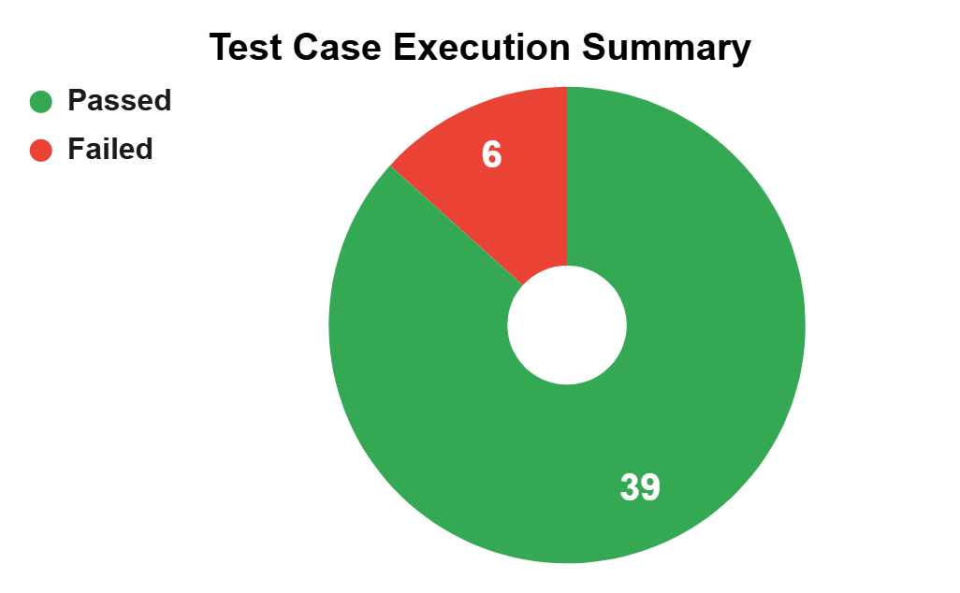
The compatibility and functional testing of the OpenCart application was conducted across key user flows, including Registration, Login, Change Password, and Cart Flow on multiple browsers.
A total of 45 test cases were executed:
- 39 test cases passed
- 6 test cases failed
- 0 blocked or skipped cases
The Change Password feature recorded 2 failures out of 10 test cases, while the Cart Flow had 1 failure out of 8 test cases, indicating minor issues within critical user journeys.
The application shows a high success rate of approximately 87%, indicating that its core functionalities are stable and generally consistent across supported browsers like Google Chrome and Mozilla Firefox. However, the identified failures reveal areas that need improvement to ensure a smooth user experience.

5. Defect Summary

Defect Severity | Critical | High | Medium | Low | Count
Feature 1 |  | 2 |  |  | 2
Feature 2 |  |  | 1 |  | 1
Feature 3 |  | 2 |  |  | 2
Feature 4 |  |  | 1 |  | 1

6. Key Findings / Observations

Some issues were found in the Registration, Login, Change Password, and Cart Flow, particularly with Change Password and Cart Flow.

7. Recommendations

1. Fix Identified Defects
- Investigate and resolve the 6 failed test cases, especially within:
- Change Password (security-sensitive)
- Cart Flow (revenue-impacting)
2. Improve Password Policy
- Enforce stronger password rules:
- Minimum of 8 characters
- Combination of uppercase, lowercase, numbers, and special characters
- Prevent acceptance of weak passwords (e.g., “wert”)

3. Enhance Cart Stability
- Ensure:
- Items are consistently added/removed
- Quantity updates correctly
- Cart persists across sessions and browsers

8. Conclusion
Testing of the OpenCart application for key functionalities: Registration, Login, Change Password, and Cart Flow on Google Chrome and Mozilla Firefox shows a largely stable system. Out of 45 test cases, 39 passed, indicating strong reliability. However, the 6 failed cases, especially in Change Password and Cart Flow, point to critical areas that need improvement for security and transactions.
Addressing these defects and enhancing password security policies will strengthen the system and improve user experience.

